**St. Francis Institute of Technology Borivli (West), Mumbai-400103**

**(Autonomous Institute)**

**Department of Information Technology**

**Sub: Internet Programming**

**Experiment – 3: JavaScript Control Structures and DOM methods**

**1. Aim:** To design a registration form using HTML and CSS. Use JavaScript to validate the user input and handle form submission using control structures.

**2. Objective: T**o understandand the basic concepts of Document Object Model and JavaScript including use of Variables, Operators, Conditions and Loops

**3. Lab objective mapped:** Students will be able to **implement** JavaScript to **develop** interactive web pages (PO3, PO5, PSO3, PSO4)

**4. Prerequisite:**JavaScript

**5. Requirements:** The following are the requirements **–**

• PC/Laptop, Visual Studio Code, Browser

**6. Pre-Experiment Theory:**

JavaScript is the programming language of the Web. JavaScript tis used o program the behaviour of web pages.

• JavaScript can change HTML content. One of many JavaScript HTML methods is getElementById()

• JavaScript can change HTML Attribute Values

• JavaScript can change HTML Styles

A JavaScript function is a block of JavaScript code, that can be executed when "called" for. Scripts can also be placed in external files

JavaScript can "display" data in different ways:

• Writing into an HTML element, using innerHTML.

• Writing into the HTML output using document.write().

• Writing into an alert box, using window.alert().

• Writing into the browser console, using console.log().

There are 3 ways to declare a JavaScript variable:

• Using var, Using let and Using const

JavaScript Operators

• Arithmetic Operators

• Assignment Operators

• String Operators

• Comparison Operators

• Logical Operators

• Type Operators

• Bitwise Operators

**1 |Internet Programming Lab**

In JavaScript we have the following conditional statements:

• Use if to specify a block of code to be executed, if a specified condition is true • Use else to specify a block of code to be executed, if the same condition is false • Use else if to specify a new condition to test, if the first condition is false • Use switch to specify many alternative blocks of code to be executed

JavaScript supports different kinds of loops:

• for - loops through a block of code a number of times

• for/in - loops through the properties of an object

• for/of - loops through the values of an iterable object

• while - loops through a block of code while a specified condition is true • do/while - also loops through a block of code while a specified condition is true

**7. Laboratory Exercise:**

**A. Procedure**

Follow the procedure given below to design a registration form and validate fields: 1. Open visual studio code.

2. Open a new file and write HTML code using its elements to design a registration form. 3. Use script tag to write the code to validate fields.

4. Save file as .html

5. Style the form using CSS markup language.

6. To view the output, right click the file and select open with option.

7. Check the output

**B. Program Code**

Design a registration form using HTML and CSS. Validate the mandatory fields e.g. firstname, lastname and format of password on form submission using control structures and DOM methods.

**8. Post Experimental Exercise**

1. Write JavaScript program to find factorial of a number.

2. Write JavaScript program to print Fibonacci series up to 10 numbers.

**9. Results/Observations/Program output:**

Present the program code and output

**10. Conclusion:**

Write what was performed in the experiment

Write which all features of JavaScript you used to perform the experiment

**11. References:**

▪ HTML 5 Black Book (Covers CSS3, JavaScript, XML, XHTML, AJAX, PHP, jQuery) 2Ed., DT Editorial Services

▪ https://www.w3schools.com/js/default.asp

▪ https://www.tutorialspoint.com/javascript/index.htm

▪ https://www.youtube.com/watch?v=W6NZfCO5SIk

▪ <https://www.youtube.com/watch?v=PkZNo7MFNFg>

**B. Program Code:**

HTML CODE SNIPPET(js reference):

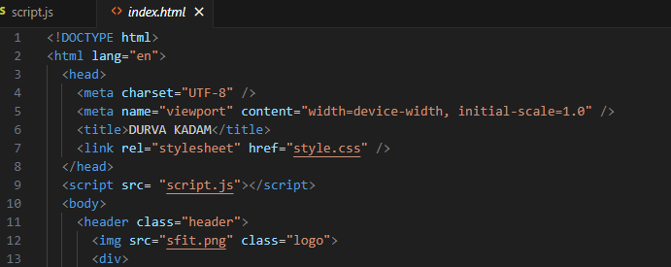

JAVASCRIPT CODE:

function validate() {

let x1 = document.forms["myform"]["fname"].value;

if (x1 === "") {

alert("Please enter your first name.");

return false;

}

let x2 = document.forms["myform"]["mname"].value;

if (x2 === "") {

alert("Please enter your middle name.");

return false;

}

let x3 = document.forms["myform"]["lname"].value;

if (x3 === "") {

alert("Please enter your last name.");

return false;

}

let x4 = document.getElementById("pswd").value;

if (x4 === "") {

alert("Please enter the password.");

return false;

}

if (x4.length > 15) {

alert("Password length must not exceed 15 characters.");

return false;

}

if (x4.length < 8) {

alert("Password length must be at least 8 characters.");

return false; }

let x5 = document.getElementById("confpswd").value;

if (x5 === "") {

alert("Please confirm your password.");

return false;}

if (x4 !== x5) {

alert("Passwords do not match.");

return false; }

let x6 = document.forms["myform"]["add"].value;

if (x6 === "") {

alert("Please enter your address.");

return false;

}

let option = document.getElementsByName("flexRadioDefault");

if (!(option[0].checked || option[1].checked || option[2].checked)){

alert("Please select the gender.");

return false; }

let fileInput = document.getElementById("inputGroupFile04");

if (fileInput.files.length === 0) {

alert("Please upload your CET Score Card.");

return false;

}

return true;

}

**SCREENSHOTS:**

1. **Name field Validations:**

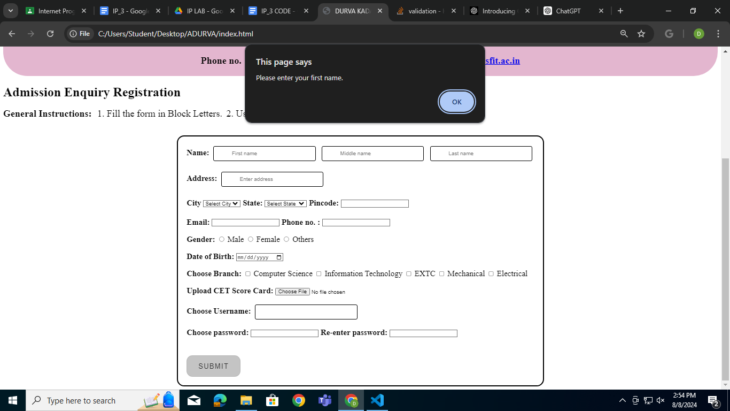

**2. Address Validation:**

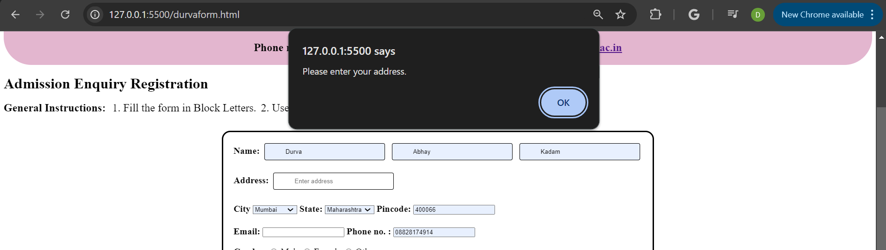

**3. Radio Button Validations:**

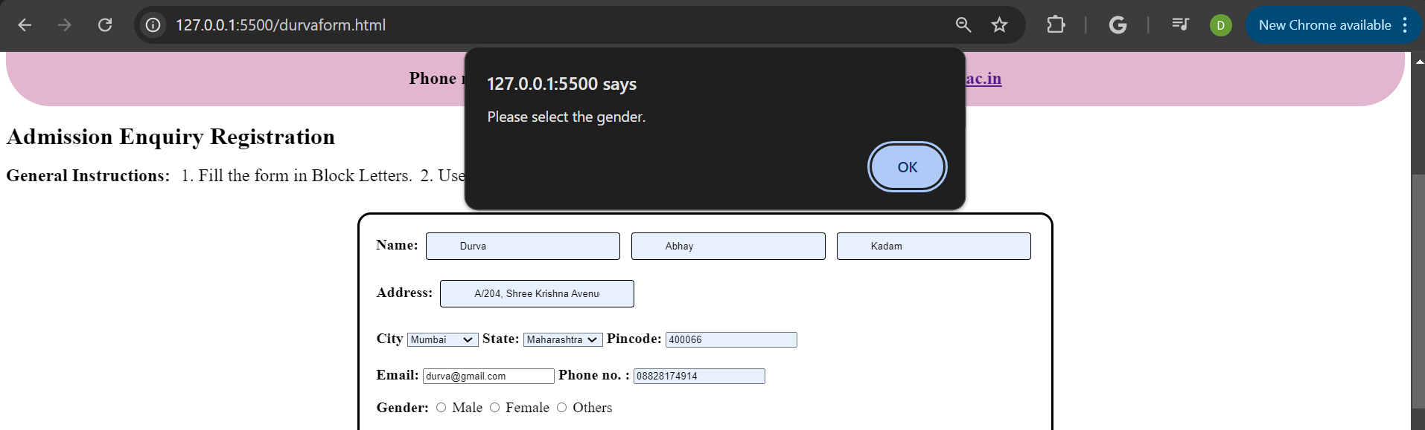

**4. Password Validation:**

1. **For empty password fields:**

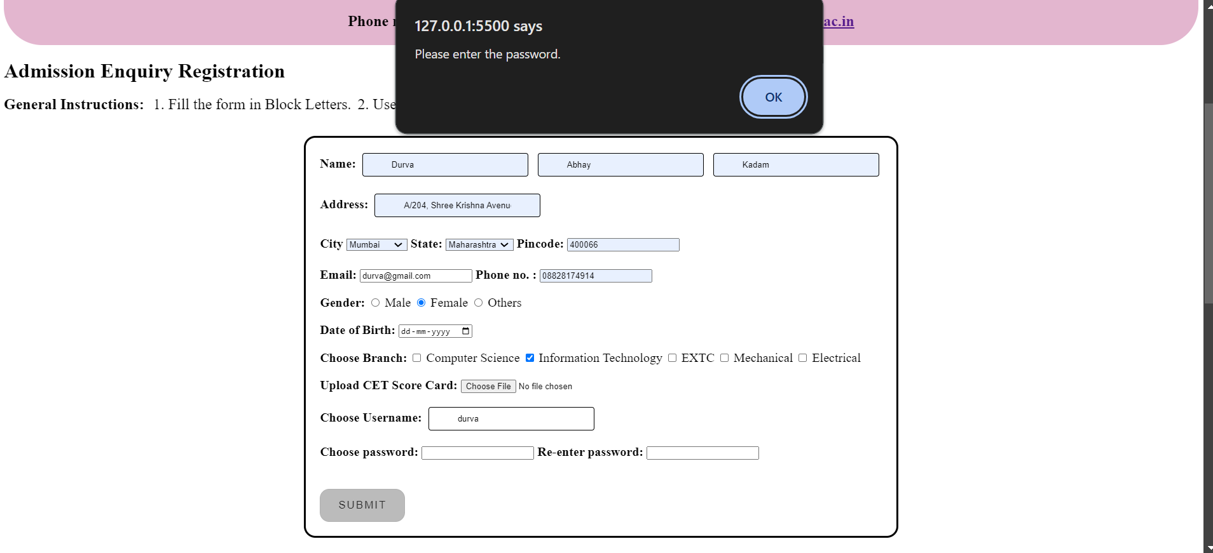

1. **Character Length Validation:**

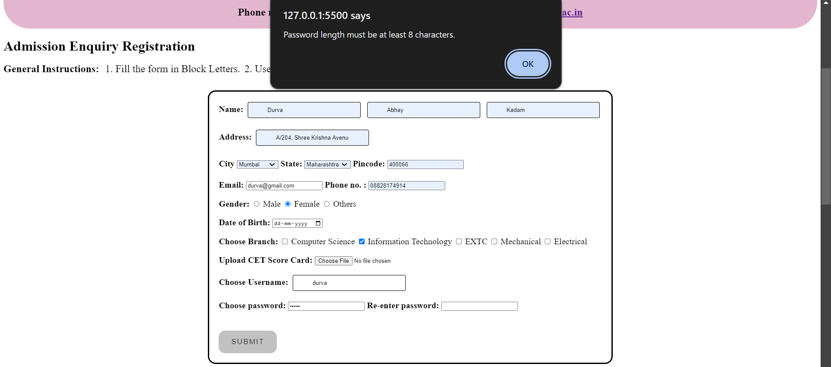

1. **Match the passwords Validation:**

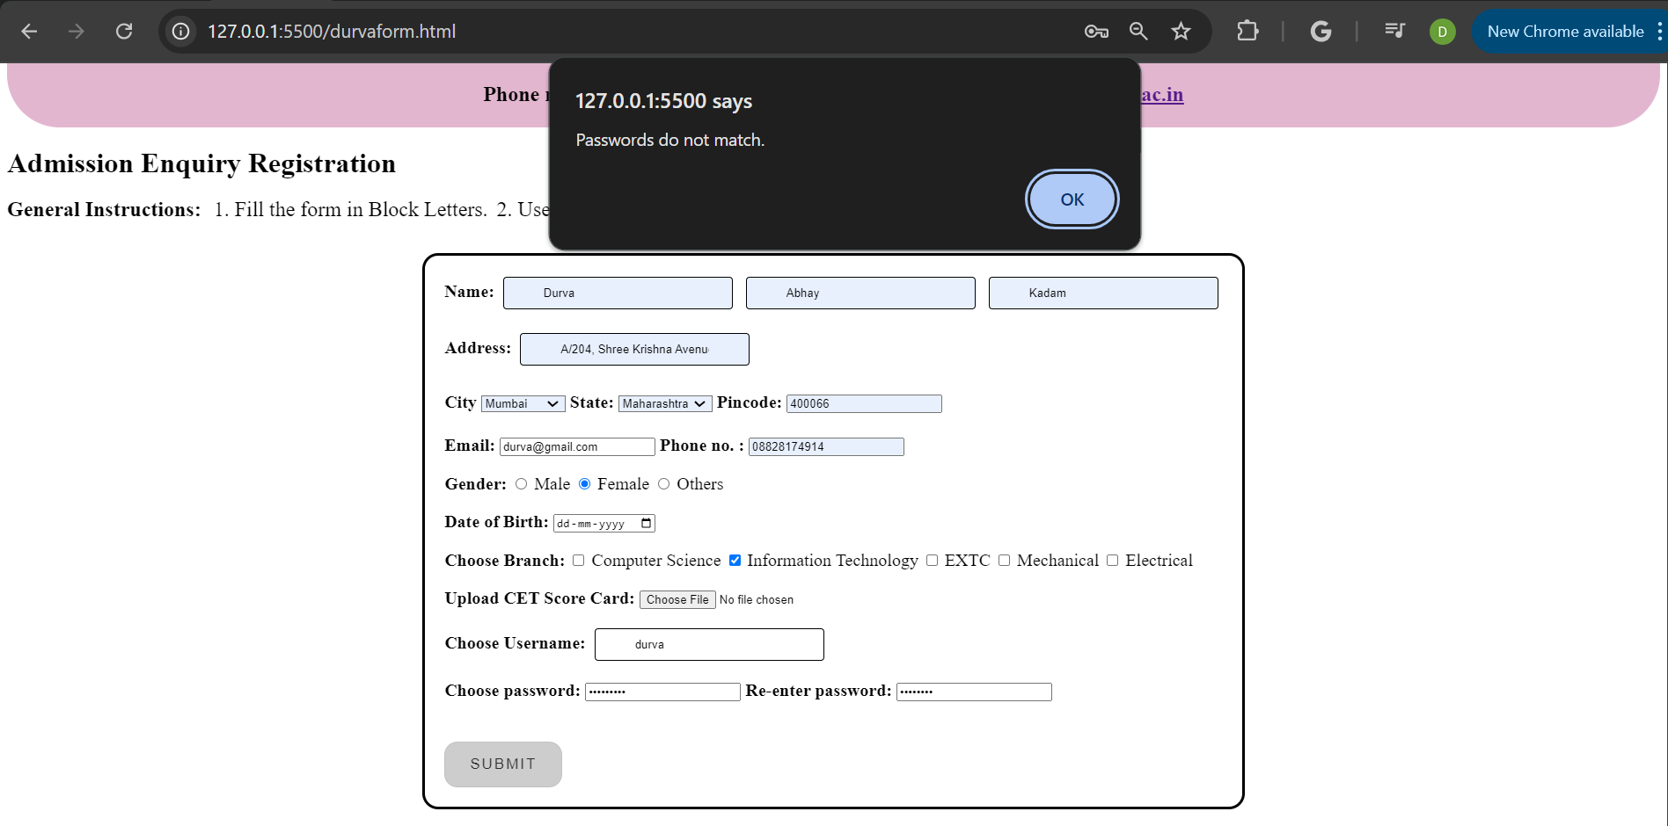

**5. Empty File Validation:**

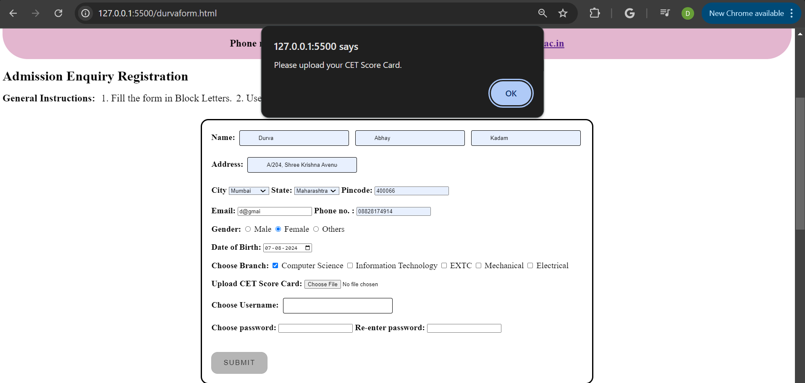

**8. Post Experimental Exercise:**

**1. Write a JavaScript program to find the factorial of a number.**

**CODE:**

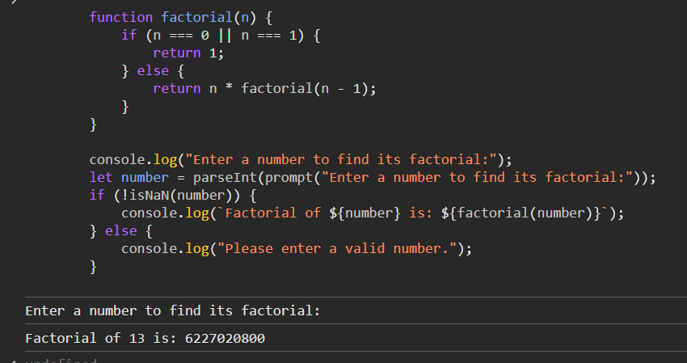

**OUTPUT:**



**2. Write a JavaScript program to print Fibonacci series up to 10 numbers.**

**CODE:**

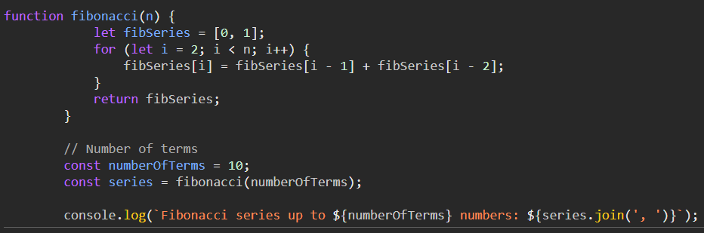

**OUTPUT:**